Tristan Izlar

COP 2360 C# Programming I

# Module 2 – Tutorial 3-5

SCREENSHOT:

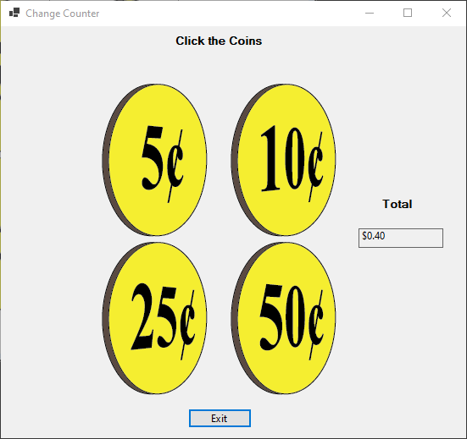

CODE:

using System;

using System.Collections.Generic;

using System.ComponentModel;

using System.Data;

using System.Drawing;

using System.Linq;

using System.Text;

using System.Threading.Tasks;

using System.Windows.Forms;

namespace Change_Counter

{

public partial class Form1 : Form

{

//Constant Fields

const decimal FIVE_CENTS_VALUE = .05m;

const decimal TEN_CENTS_VALUE = .10m;

const decimal TWENTY_FIVE_CENTS_VALUE = .25m;

const decimal FIFTY_CENTS_VALUE = .50m;

//Field for Running Total

private decimal total = 0.00m;

public Form1()

{

InitializeComponent();

}

//Exit Button

private void exitButton_Click(object sender, EventArgs e)

{

this.Close();

}

//Five Cents Image

private void fiveCentsPictureBox_Click(object sender, EventArgs e)

{

total += FIVE_CENTS_VALUE;

totalLabel.Text = total.ToString("c");

}

//Ten Cents Image

private void tenCentsPictureBox_Click(object sender, EventArgs e)

{

total += TEN_CENTS_VALUE;

totalLabel.Text = total.ToString("c");

}

//Twenty Five Cents Image

private void twentyFiveCentsPictureBox_Click(object sender, EventArgs e)

{

total += TWENTY_FIVE_CENTS_VALUE;

totalLabel.Text = total.ToString("c");

}

//Fifty Cents Image

private void fiftyCentsPictureBox_Click(object sender, EventArgs e)

{

total += FIFTY_CENTS_VALUE;

totalLabel.Text = total.ToString("c");

}

}

}